**MODULE : 1**

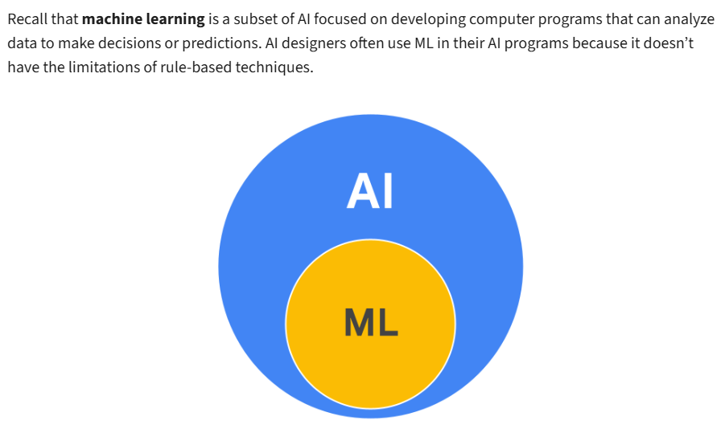

**Approaches to Training Machine Learning (ML) Programs**

There are three common approaches to training ML models:

* **Supervised learning**
* **Unsupervised learning**
* **Reinforcement learning**

**Supervised Learning**  
AI designers provide a labeled dataset—where inputs are tagged with expected outputs. The model learns from these examples. For example, a spam filter trained with emails labeled as "spam" or "not spam." This approach is ideal when a specific outcome is required.

**Unsupervised Learning**  
Here, the model is given an unlabeled dataset. It identifies hidden patterns or groupings without predefined categories. For instance, analyzing unsorted emails to detect topics or trends. This method is useful when there's no clear output in mind.

**Reinforcement Learning**  
The model learns through trial-and-error, receiving rewards for correct actions. Over time, it optimizes behavior based on feedback. This is common in conversational AI, where tools improve by interacting with users.

**Generative AI**  
Advancements in all three ML approaches have enabled **generative AI**—AI that creates new content like text, images, or media in response to user prompts. Each ML method contributes:

* **Supervised learning** provides a base of structured responses.
* **Unsupervised learning** helps interpret natural language variations.
* **Reinforcement learning** fine-tunes responses based on feedback.

**Benefits of Generative AI in the Workplace**

* **Efficiency**: Automates routine tasks, freeing up time for high-value work.
* **Personalization**: Adapts interactions based on user preferences.
* **Insight**: Analyzes data rapidly to support informed decisions.

Together, these advancements enable smarter, more adaptable AI systems that enhance productivity and creativity across industries.

  
  
  
  
  
  
  
  
  
  
  
  
  
  
  
